My understanding for the model:

My understanding of DTD is based on the Merton structural framework. Equity can be viewed as a call option on a firm's assets. Since the daily asset value and asset volatility are not directly observable, equity market information can be used to infer the firm's underlying asset value and risk, which are then compared with a default barrier to derive DTD. For my project, I set the default-barrier parameter to 0.5. Therefore, I interpret the model as a market-based measure of how close the firm is perceived to be to a distressed credit state(go bankrupt).

To examine this relationship, I first compare the daily percentage changes in Vanke's market capitalization and DTD. The daily series are relatively noisy, but after applying a 20-day moving average, the relationship between the two becomes much clearer. This suggests that DTD is strongly connected to changes in equity-market perceptions.

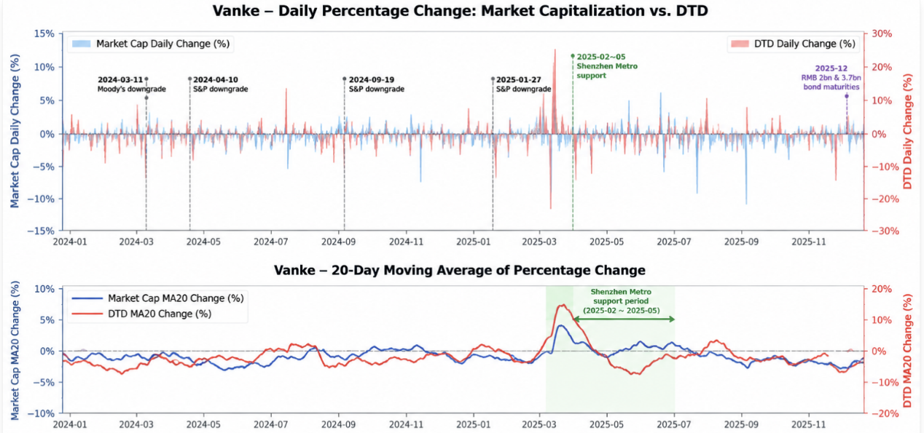
I then find one interesting questions:

If DTD is a market-based credit-risk signal, does it identify deterioration before actual credit or default-related events occur? To investigate this, I compare the historical DTD series with Vanke's rating actions, financial reports and major credit events.

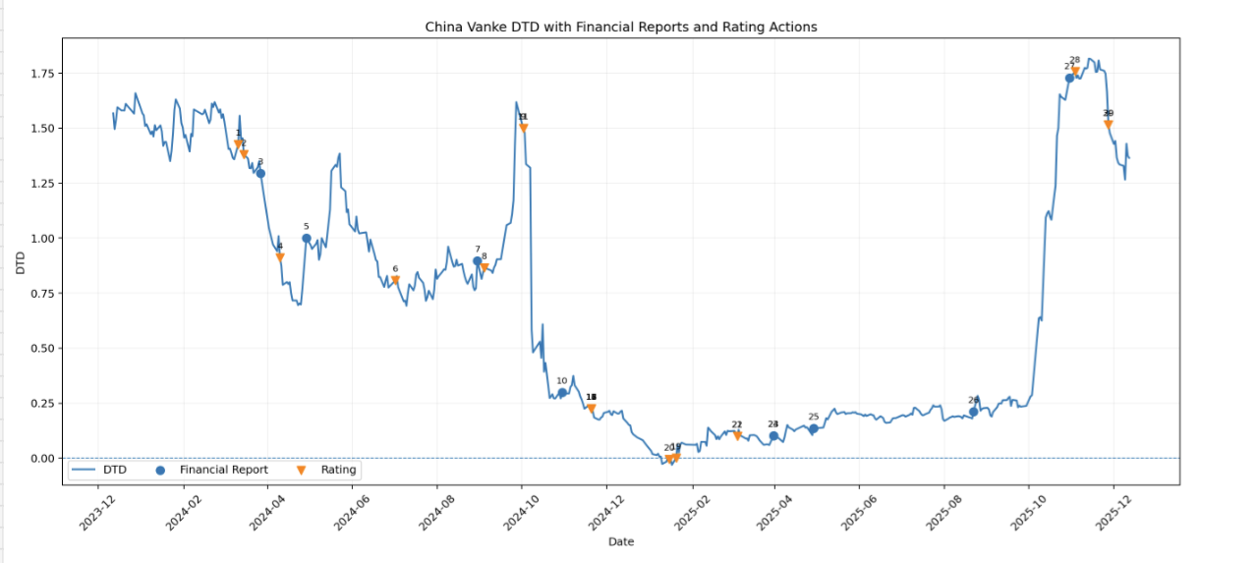
My Findings:

Point1: DTD often deteriorates before formal credit events

The first interesting observation is that Vanke experienced multiple rating downgrades during the sample period, but DTD did not simply begin falling after these rating actions. In several cases, the pattern appears to be:

DTD starts declining → rating downgrade / credit event occurs → DTD declines further

This suggests that the market may have already become concerned about Vanke's creditworthiness before the rating agency formally confirmed the deterioration.

My interpretation is therefore that DTD reflects changes in market perception rather than waiting for a formal credit event to confirm that the firm's condition has deteriorated. A company may still be meeting its debt obligations, while investors have already become increasingly concerned about its future repayment capacity.

This is where I see the early-warning characteristic of DTD: market-implied credit deterioration can appear before the corresponding deterioration becomes a formal rating or default event.

Point 2: The lowest DTD did not coincide with the actual default-related event

The second observation is the most interesting result in the Vanke case. Around the end of 2024, Vanke's DTD fell to almost zero, one of the lowest levels in the entire sample. Intuitively, this indicates that the market perceived Vanke as being extremely close to a distressed credit state.However, Vanke had not yet defaulted on its public bonds at that point.
The situation then became counter-intuitive in 2025. Following management changes and increasing liquidity support from Shenzhen Metro, market confidence improved. Vanke's equity value recovered and DTD increased substantially. However: An improvement in DTD did not necessarily mean that Vanke's standalone repayment capacity had improved by the same degree. As Vanke was becoming increasingly dependent on external liquidity support to meet its debt obligations.

For my understanding, this highlights an important finding for me with the relationship of stock and the company debt.The market believing that someone will support the company is not the same as the company being able to repay its debt independently.

If policy support, shareholder assistance or improving sentiment causes the equity market to become more optimistic, DTD can improve rapidly even though the underlying debt burden has not disappeared.
This feature creates an interpretation problem. When DTD changes, it may be difficult to determine whether the movement is caused by: Vanke's own fundamental credit condition, changes in the property sector, macroeconomic expectations, policy intervention, or general market sentiment.

Therefore, DTD tells us effectively that the market's perception of risk has changed, but it does not necessarily tell us why the risk has changed or whether the firm's underlying repayment capacity has changed for this period.

